192521377-SUBASHREE.N

LAB EXPERIMENTS
DML Commands – INSERT, SELECT
Exp 3:

OUTPUT:
1:
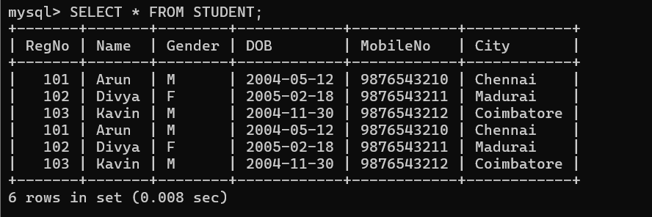

2:
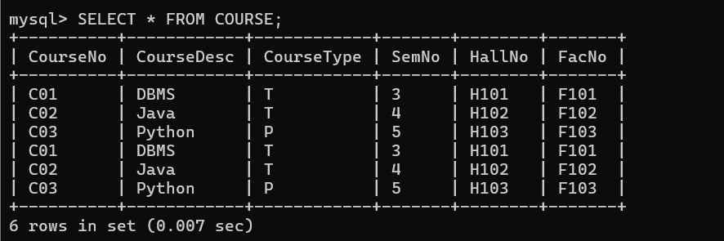

3:
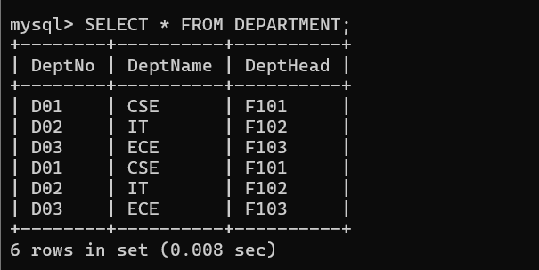

4:
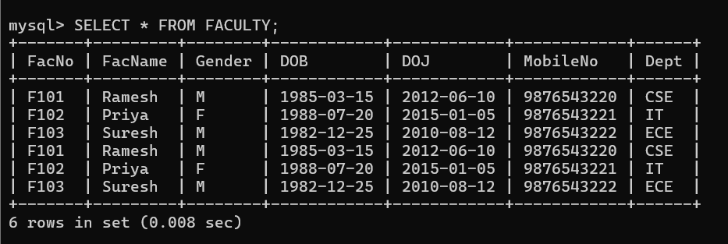

EXP 4:
DML Commands with Constraints –UPDATE, DELETE
OUTPUT:
1:
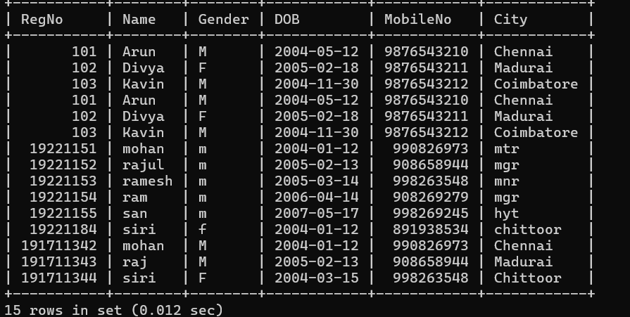

2:
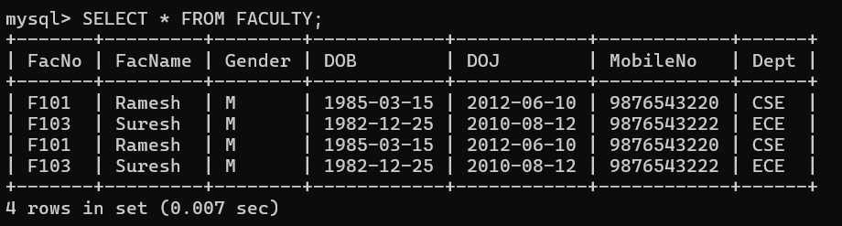

3:
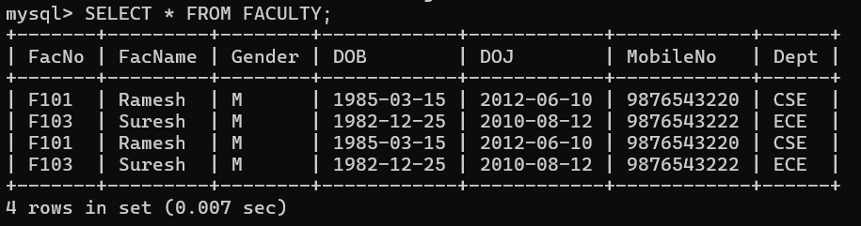
4:


